Time Trial Event

Open Time Trial – 04th September 2022

Starts at 07:31
On course U47/R (10 miles)
Promoted for and on behalf of Cycling Time Trials under their Rules and Regulations
Timekeepers: Sue Andrews and Doug Gale
Event Secretary: David Wright, 24 Matthews Walk, Cirencester, GL7 1HL
Tel: 07715652408 Email: dnwright1963@gmail.com
Emergency contact on the day: David Wright 0771652408 or Joanna Hosking 07973388419

Prizes
1st Female £30 1st Male £30
2nd Female £20 2nd Male £20
1st VET Female 50-54 £10 1st VET Male 50-54 £10
1st VET Female 55-59 £10 1st VET Male 55-59 £10
1st VET Female 60-64 £10 1st VET Male 60-64 £10
1st VET Female 65-69 £10 1st VET Male 65-69 £10
1st VET Female 70-79 £10 1st VET Male 70-79 £10
1st VET Female 80-90 £10 1st VET Male 80-90 £10
There will be competitor finish times displayed at the HQ and it is our intention to have the final results on the CTT website by Sunday evening. However, due the 50% rise in costs of HQ hire, the HQ will close at 09:30 and therefore there will be no prizegiving ceremony. Prizes will be sent to competitors within 7 days of the event.

Please take time to read Important notes for competitors below

Course
The entry and exit points to the A419 will be marked with double arrows (black on white background) and the turn roundabout will be marshalled, but please be aware that it is a rider’s responsibility to know the course.
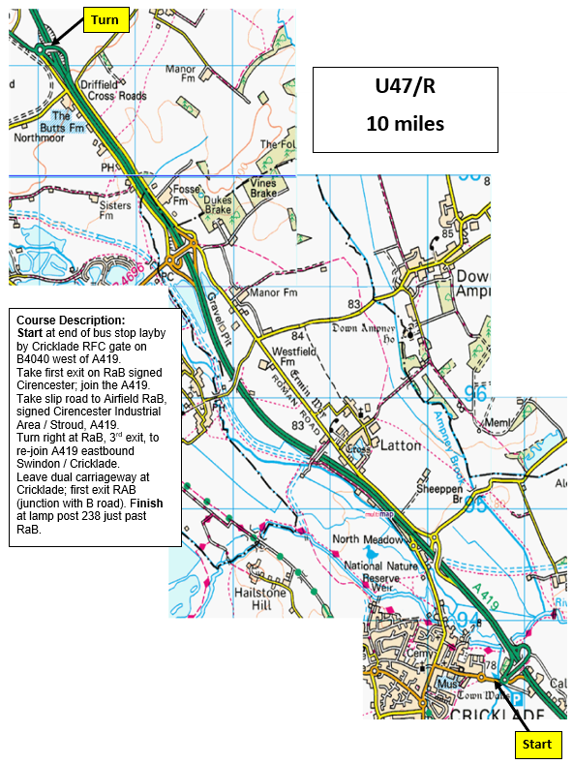

HQ

Cricklade Town Hall
High Street, Cricklade, Swindon, SN6 6AE
Open from 06:15
There is parking at the Town Hall, at the Rugby Club adjacent to the start and on local roads, but please be considerate to Cricklade residents.
START: 800 metres from HQ
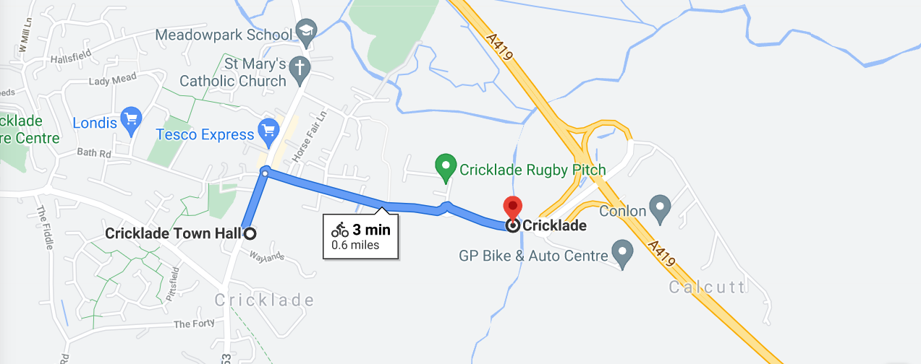
Important notes for competitors:
- Normal rules apply when passing other competitors during the event, and for avoiding drafting.
- Upon completion of their ride all competitors should sign out and return their number promptly at the HQ.
- When joining the A419, please use the full length of the slip road before moving onto the dual carriageway, to provide approaching vehicles the maximum opportunity to be aware of your presence.
- Take care at turn on roundabout – give way to traffic already on the roundabout.
- Cycling Time Trial regulations require all competitors to wear a HARD-SHELL HELMET.
- Use of working front and rear lights, either flashing or constant, are required during the event.
- Head-down riding can cause life changing injuries both to yourself and other competitors. Please keep your head up and concentrate on the road ahead.
- Should the event need to be abandoned; this will be done in accordance with CTT guidelines.

First Aid will be provided by:

